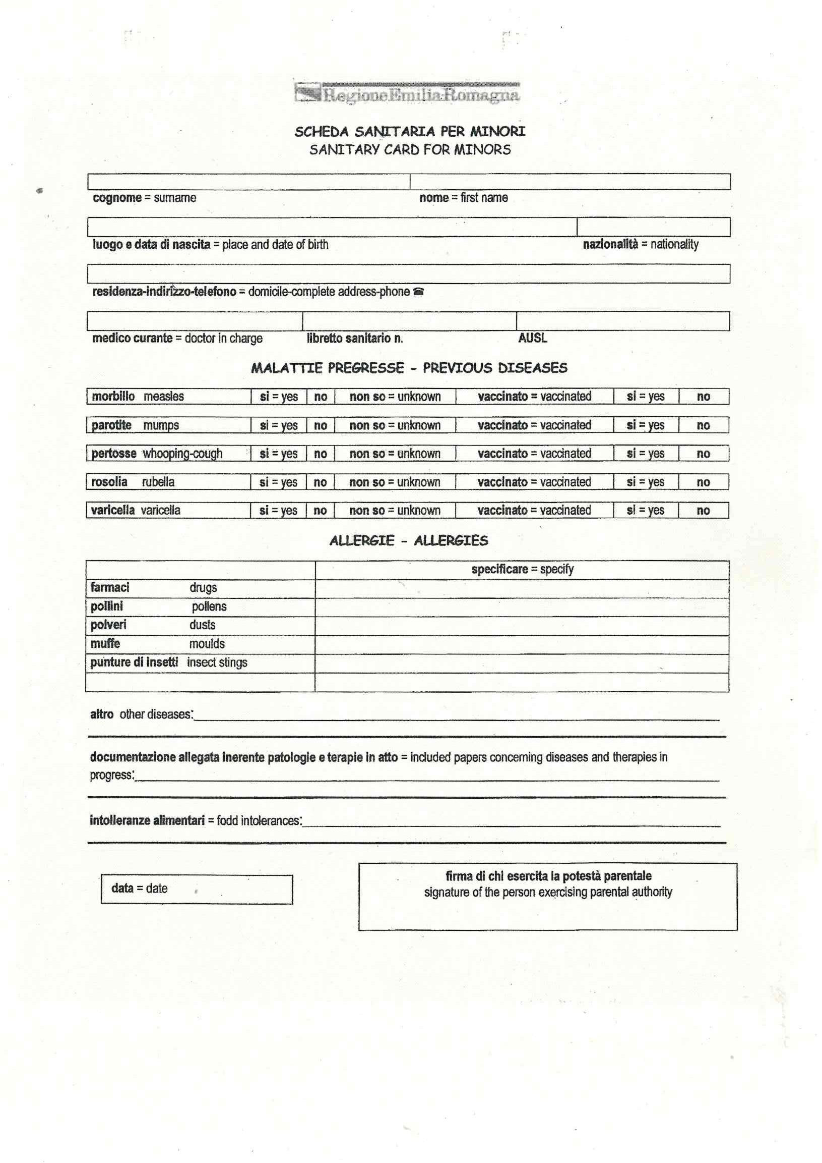

Mettere una \*

Non so -unknown

Non so -unknown

Non so -unknown

Non so -unknown

Non so -unknown

Si-yes

Si-yes

Si-yes

no

no

no

Si-yes

no

no

Si-yes

no

Si-yes

Si-yes

no

Si-yes

no

Si-yes

no

Si-yes

no